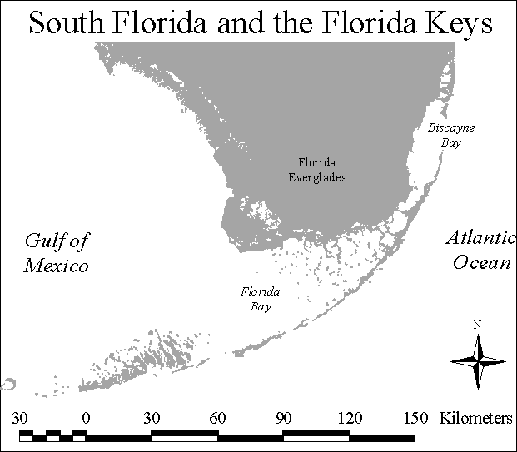 Figure 1. South Florida and the Florida Keys
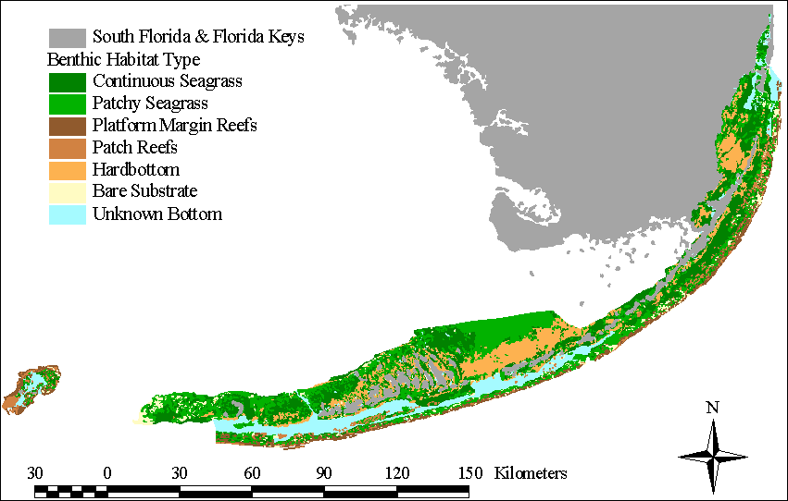
Figure 2. Benthic Habitats of the Florida Keys National Marine Sanctuary
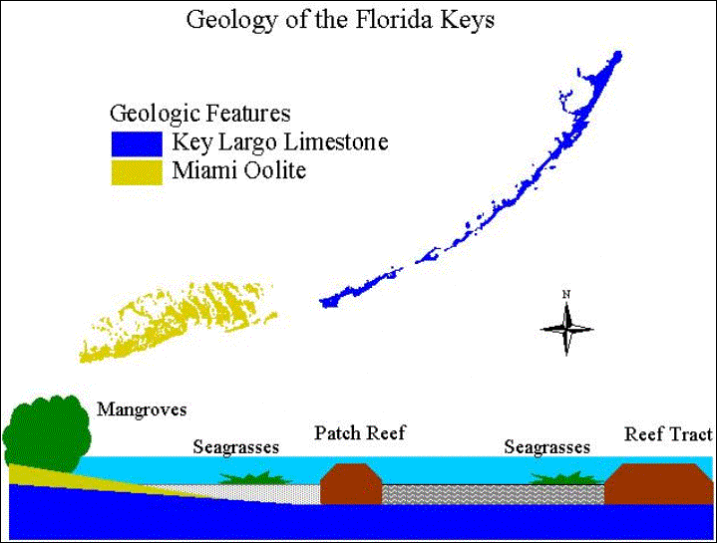Figure 3. Geology of the Florida Keys
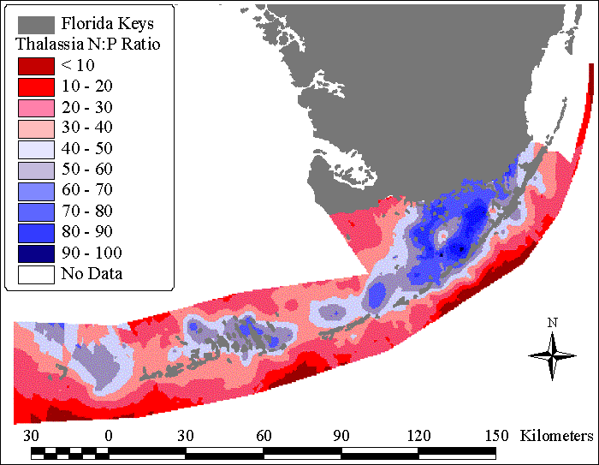Figure 4. Differences in nutrient availability shown by N:P elemental ratios of Thalassia testudinum in the upper Florida Keys
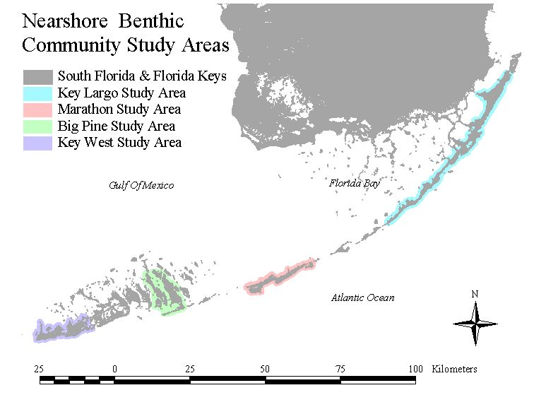Figure 6. The four nearshore benthic community study areas in the Florida Keys
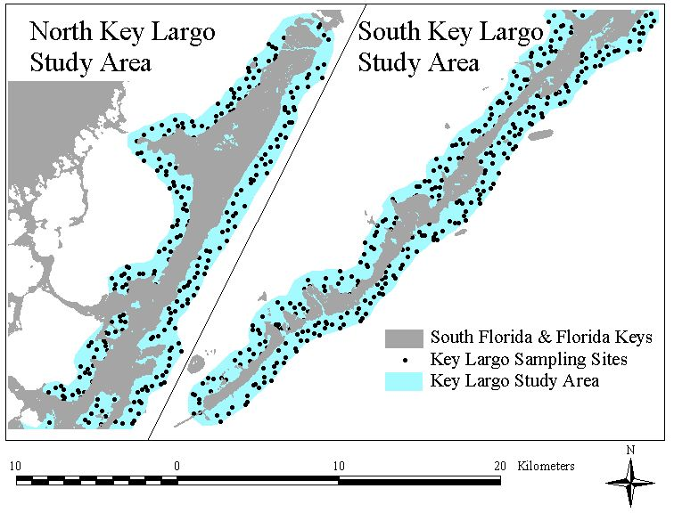 Figure 7a. Key Largo Study Area
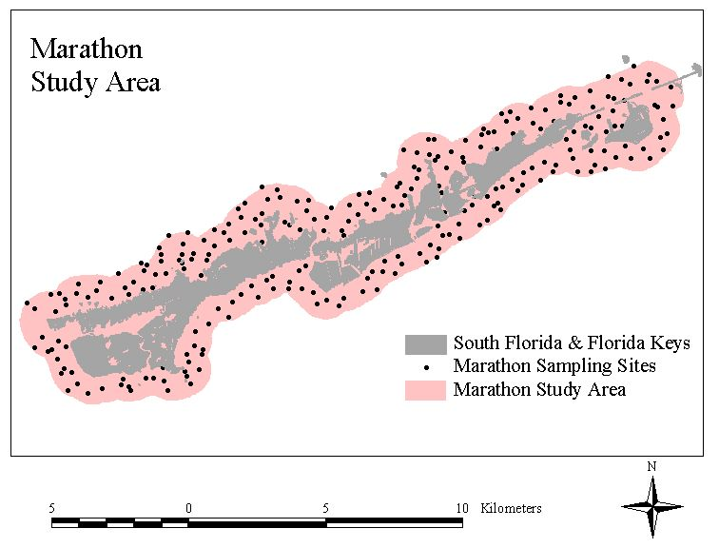Figure 7b. Marathon Study Area
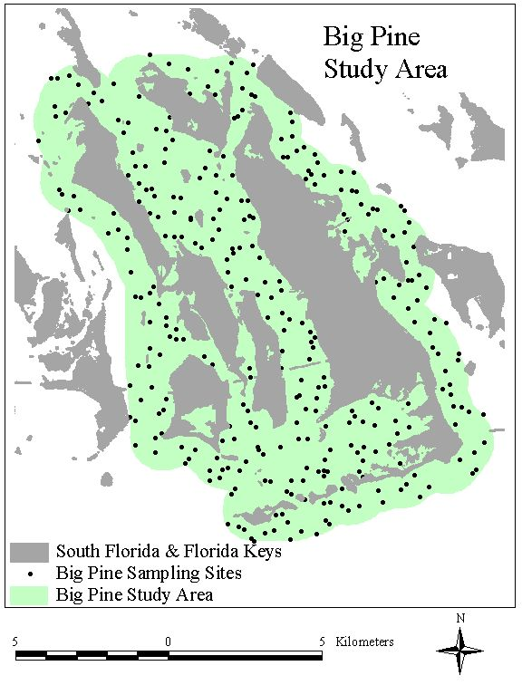Figure 7c. Big Pine Study Area
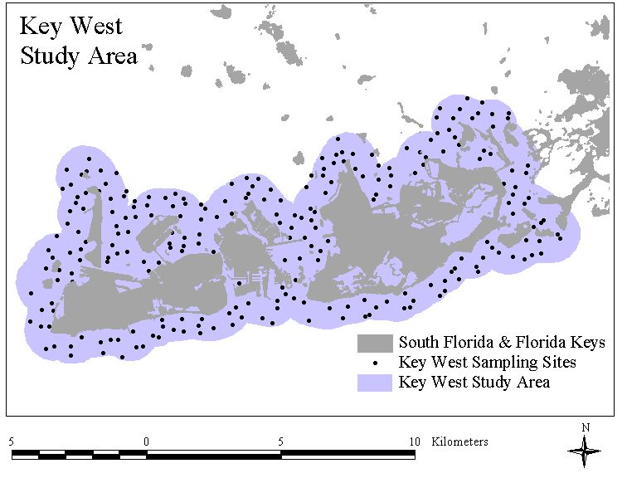Figure 7d. Key West Study Area
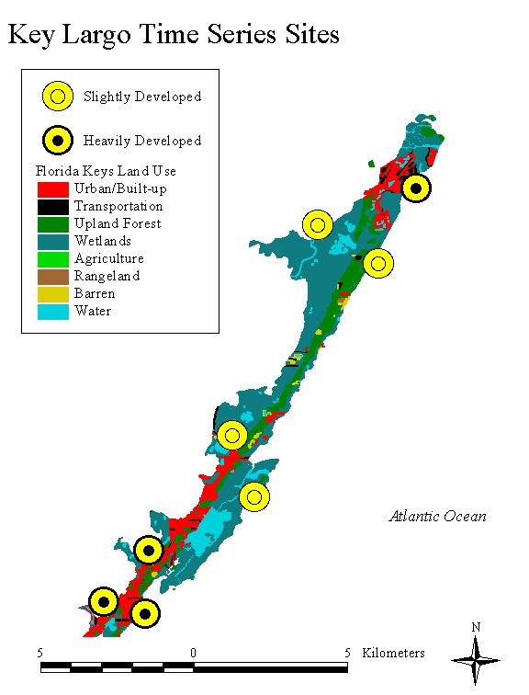

Figure 9a. Key Largo Time Series Sites

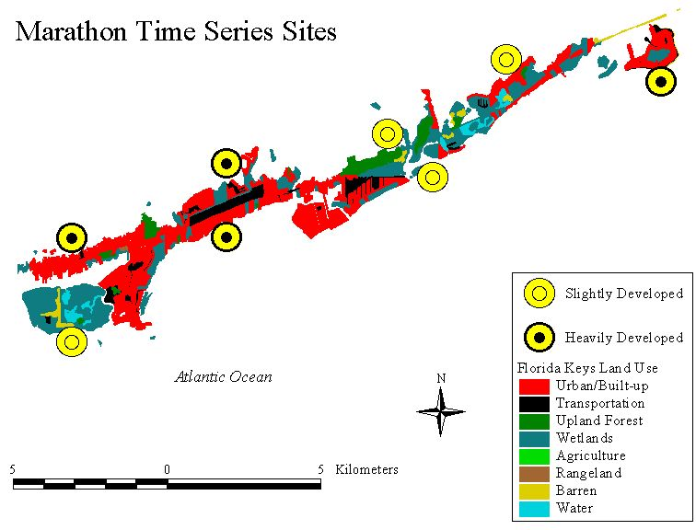
Figure 9b. Marathon Time Series Sites
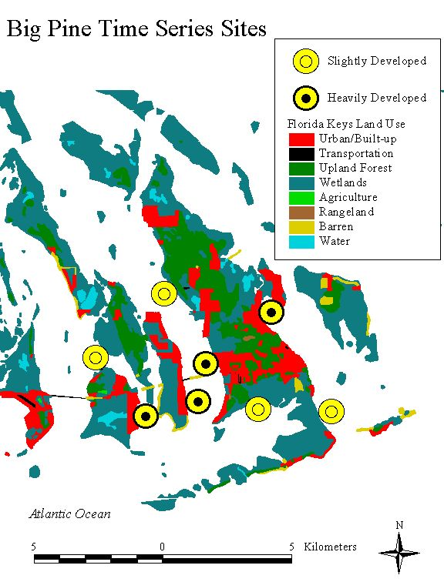
Figure 9c. Big Pine Time Series Sites
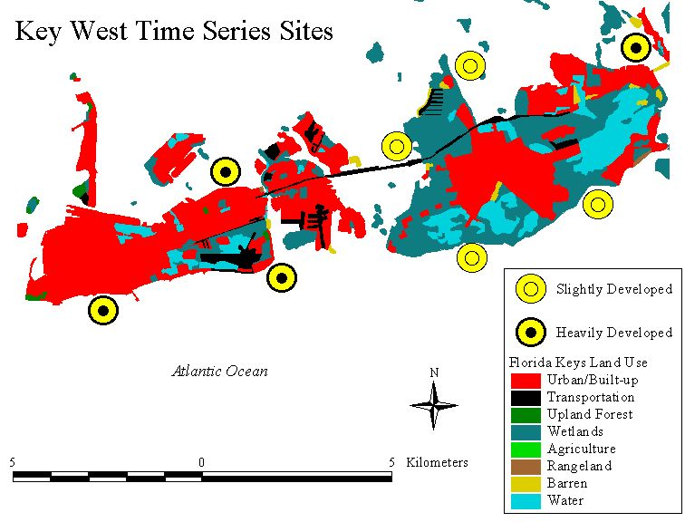
Figure 9d. Key West Time Series Sites
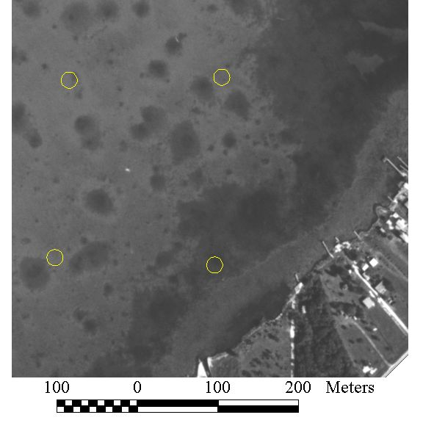
Figure 10. A small section of a DOT aerial photograph with 10 m radius buffers for data collection
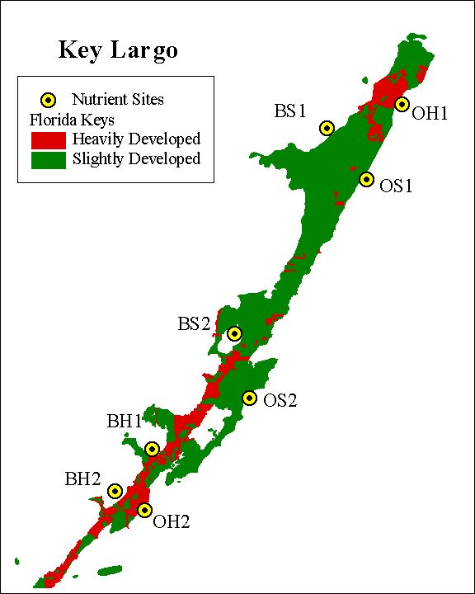
Figure 11a. Key Largo Nutrient Transect Sites
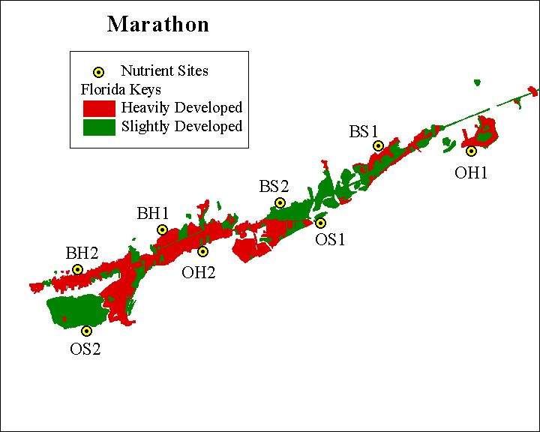
Figure 11b. Marathon Nutrient Transect Sites
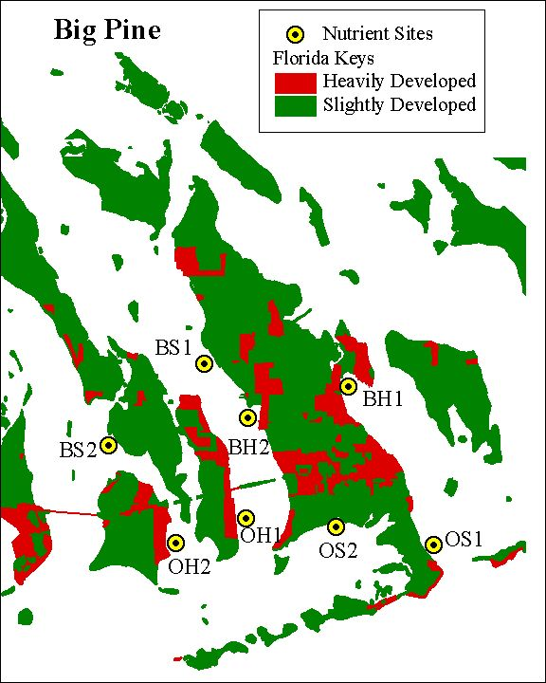
Figure 11c. Big Pine Nutrient Transect Sites
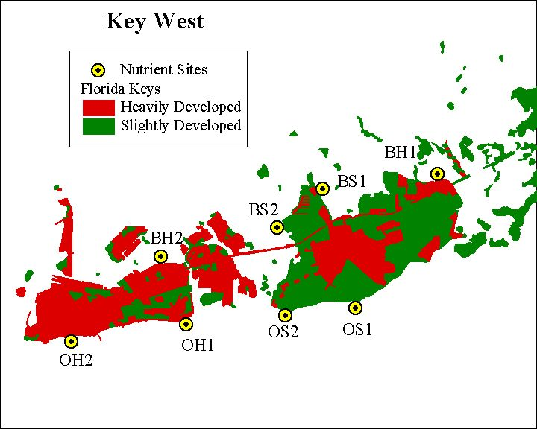
Figure 11d. Key West Nutrient Transect Sites

Figure 12. General linear model: exploring the relationship between distance from shore, land use (red=developed, green=undeveloped), distance*land use interaction, and nearshore benthic community composition
Figure 13. Radial model: Exploring the relationship between relative amount of developed land within a given radius (red=developed, green=undeveloped) and nearshore benthic community composition
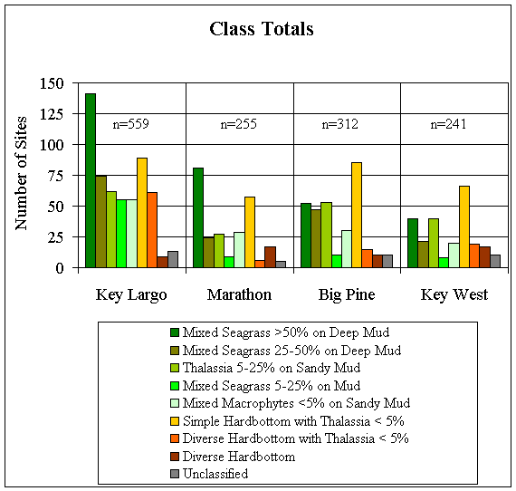
Figure 14. Classification of Nearshore Benthic Communities
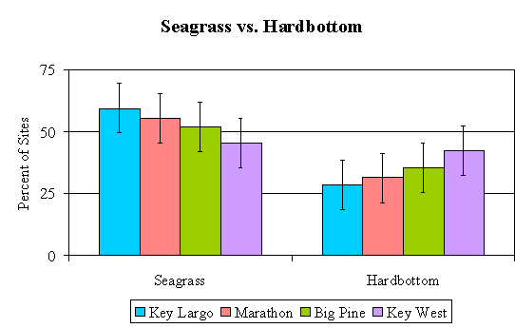
Figure 15. Percent of Seagrass and Hardbottom Communities in the Four Study Areas
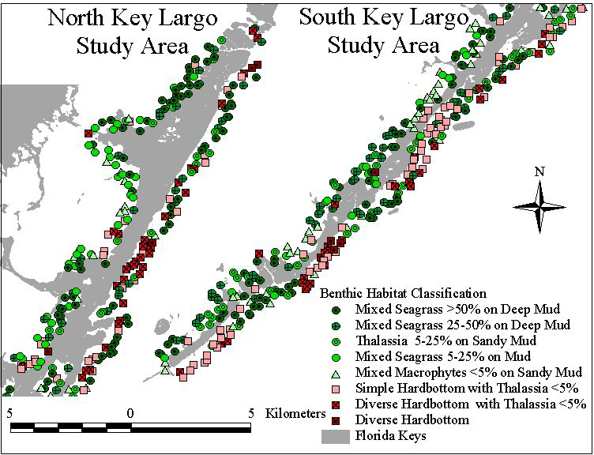
Figure 16a. Distribution of Key Largo Nearshore Benthic Communities

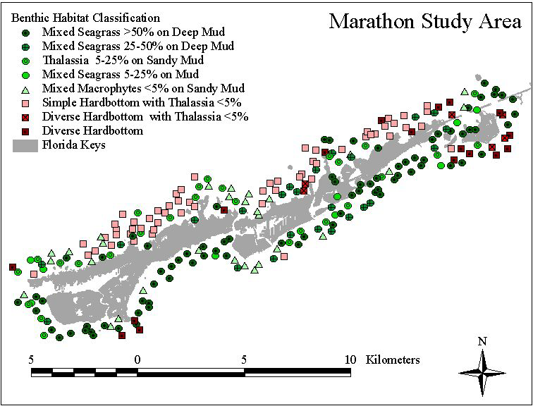
Figure 16b. Distribution of Marathon Nearshore Benthic Communities

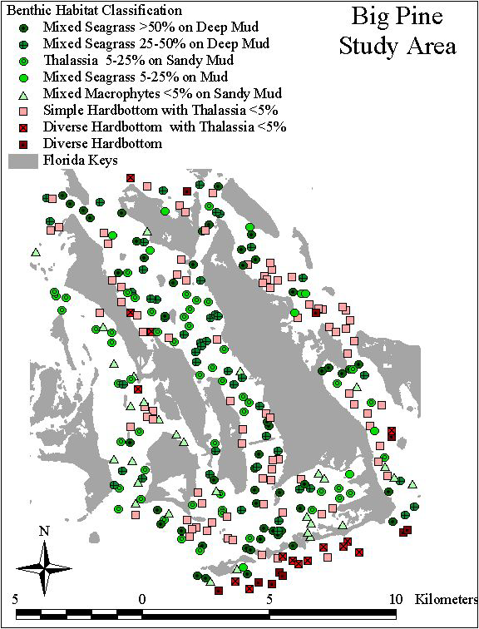
Figure 16c. Distribution of Big Pine Nearshore Benthic Communities

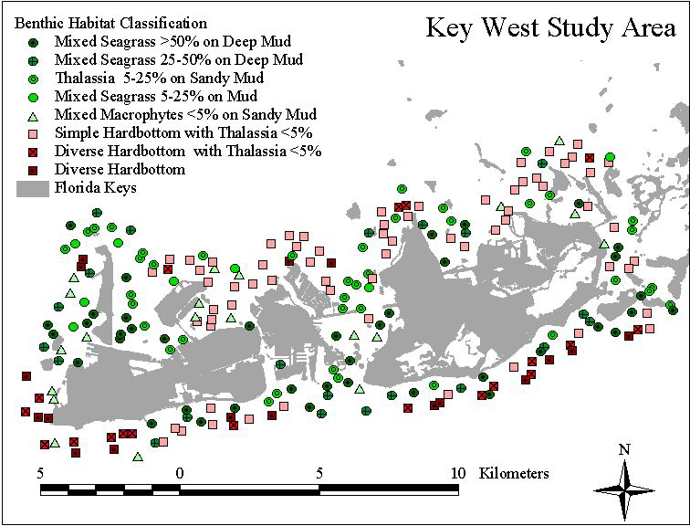
Figure 16d. Distribution of Key West Nearshore Benthic Communities
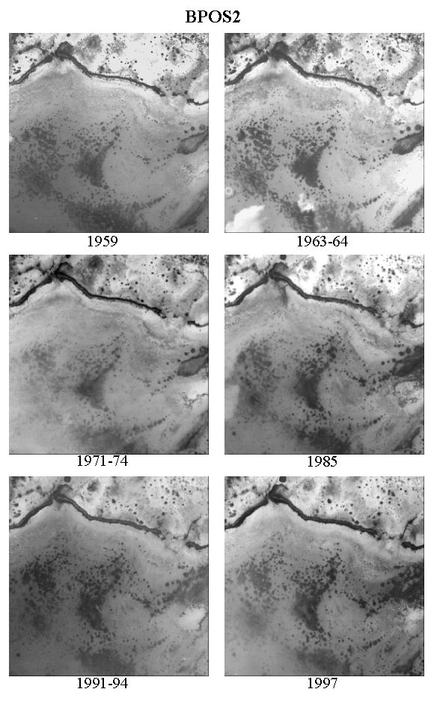
Figure 17. An example of a DOT photograph time series study site (Big Pine Key study area)
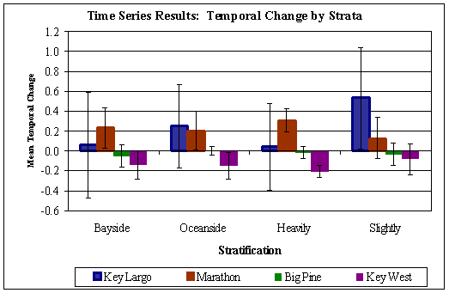
Figure 18a. Mean temporal change for DOT photograph time series analyses.

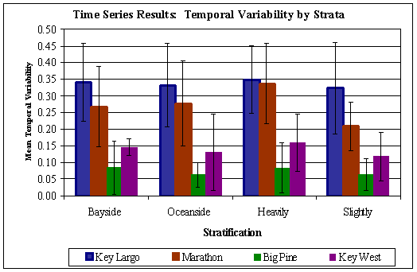
Figure 18b. Mean temporal variability for DOT photograph time series analyses.
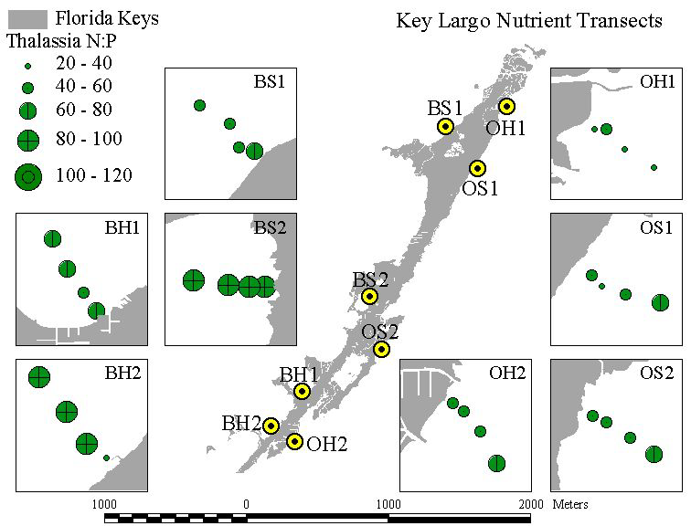
Figure 19a. Thalassia testudinum N:P plots for the Key Largo Study Area

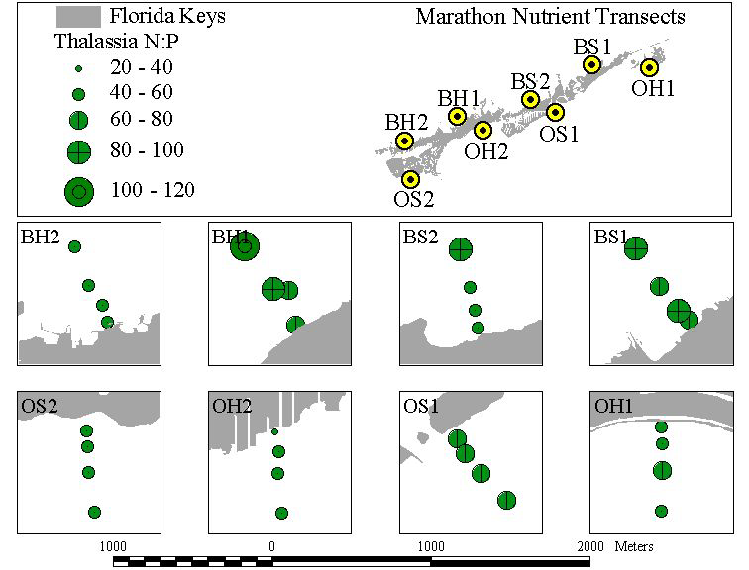
Figure 19b. Thalassia testudinum N:P plots for the Marathon Study Area

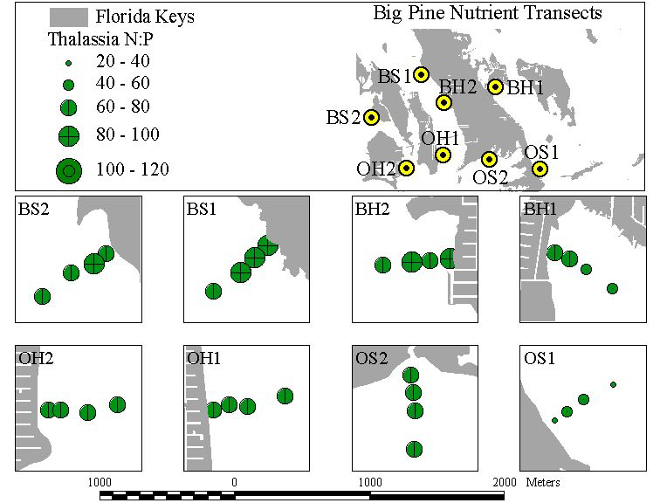
Figure 19c. Thalassia testudinum N:P plots for the Big Pine Study Area

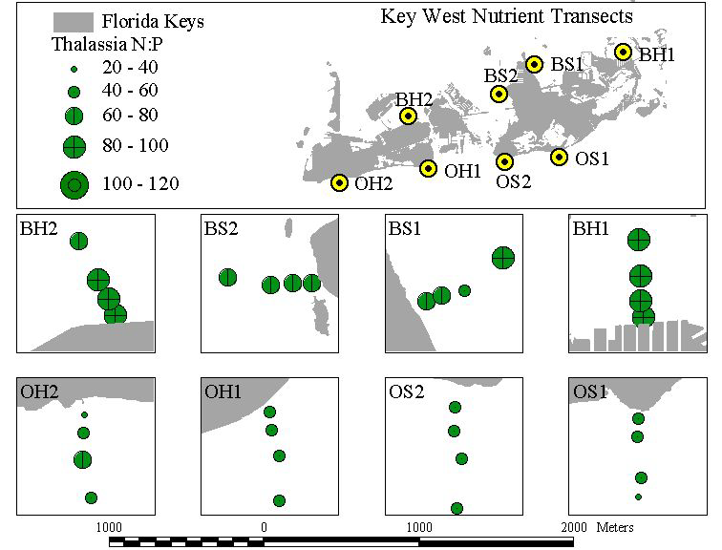
Figure 19d. Thalassia testudinum N:P plots for the Key West Study Area
Figure 20. General linear model: exploring the relationship between distance from shore, land use (red=developed, green=undeveloped), distance*land use interaction, and nearshore benthic community composition

Figure 21. Radial model: Exploring the relationship between relative amount of developed land within a given radius (red=developed, green=undeveloped) and nearshore benthic community composition
Table 1. Relevant research conducted in the Florida Keys
Author | Subject
(Powell et al. 1989) | nutrient enrichment of seagrass communities
(Zieman et al. 1989) | distribution, abundance, & productivity of seagrasses
(Lapointe et al. 1990) | sewage disposal, groundwater contamination, nearshore waters, anthropogenic eutrophication.
(Tomasko and Lapointe 1991) | water column nutrient availability, seagrass productivity
(Fourqurean et al. 1992b) | porewater nutrients and seagrass, phosphorous limitation
(Fourqurean et al. 1992a) | phosphorous limitation of primary production
(Lapointe and Clark 1992) | coastal eutrophication, onshore-to-offshore nutrient gradient, septic and groundwater discharge
(Fourqurean et al. 1993) | phosphorous limitation, water column nutrients, phytoplankton
(Lapointe et al. 1994) | coastal eutrophication and seagrass communities, onshore-to-offshore nutrient gradient
(Shinn et al. 1994) | injection well effluent, geology, groundwater nutrient transport
(Fourqurean et al. 1995) | nutrient supply effects on seagrass competition
(Lapointe and Matzie 1996) | stormwater nutrient discharge, nearshore eutrophication, runoff, wastewater, onshore-to-offshore nutrient gradient
(Swart et al. 1996) | coral, stable carbon and oxygen isotopes, climatic changes
(Szmant and Forrester 1996) | water column nutrients, sediment nutrients
(Boyer et al. 1997) | multivariate analyses of water quality parameters
(Fong et al. 1997) | seagrass ecosystem model
(Frankovich and Fourqurean 1997) | seagrass epiphyte loads along nutrient availability gradient
(Jones and Boyer 1997) | water quality monitoring
(Paul et al. 1997) | injection well effluent, groundwater nutrient transport
(Jaap et al. 1998) | status of coral reefs and hardbottom in the FKNMS
(Fourqurean et al. 1999) | status and trends in seagrass communities in the FKNMS
(Corbett et al. 1999) | groundwater discharge in Florida Bay
Table 2. Braun Blanquet scores for recording the abundance of benthic taxa.
Score | Percent cover
0.1 | Solitary, <5%
0.5 | Sparse, <5%
1 | Many, < 5%
2 | 5% - 25%
3 | 25% - 50%
4 | 50% - 75%
5 | 75% - 100%

Table 3. Benthic taxa used for nearshore benthic community surveys
Code | Taxa | Cod e | Taxa
 | Seagrasses |  | Red Algae
T | Thalassia testudinum | Geli | Genus Gelidium/ella/opsis
S | Syringodium filiforme | Liag | Family Liagoraceae
H | Halodule wrightii | Cory | Corynomorpha clavata
Hd | Halophila decipiens | Hypn | Genus Hypnea
He | Halophila engelmanni | Kall | Genus Kallymenia
R | Ruppia maritima | Euch | Eucheuma isiforme
 | Calcareous Green Algae | Hlym | Genus Halymenia
Hali | Genus Halimeda | Grac | Genus Gracilaria
Peni | Genus Penicillus | Cham | Genus Champia
Udot | Genus Udotea | Botr | Genus Botryocladia
Ripo | Genus Ripocephalus | Cera | Genus Ceramium
Acet | Genus Acetabularia | Dsya | Genus Dasya
Neom | Genus Neomeris | Hsip | Heterosiphonia gibbesii
Cymo | Cymopolia barbata | Acan | Genus Acanthophora
 | Green Algae | Bryo | Genus Bryothamnion
Ente | Genus Enteromorpha | Chon | Genus Chondria
Ulva | Genus Ulva | Dige | Digenea simplex
Anad | Genus Anadyomene | Laur | Genus Laurencia
Micr | Genus Microdictyon |  | Brown Algae
Chae | Genus Chaetomorpha | Rose | Genus Rosenvingea
Clad | Genus Cladophora | Dopt | Genus Dictyopteris
Dsph | Genus Dictyosphaeria | Dict | Genus Dictyota
Vent | Ventricaria ventricosa | Lobo | Lobophora variegata
Valo | Genus Valonia | Padi | Genus Padina
Codi | Genus Codium | Styp | Stypopodium zonale
Caul | Genus Caulerpa | Sarg | Genus Sargassum
Avra | Genus Avrainvillea | Turb | Genus Turbinaria
Bato | Genus Batophora |  | Stony Corals
Dasy | Dasycladus vermicularis | Malc | Millepora alcicornis
 | Octocorals | Ppor | Porites porites
Basb | Briareum asbestinum | Past | Porites asteroids
Ecar | Erythropodium caribaeorum | Carb | Cladocora arbuscula
Phom | Plexaura homomalla | Orob | Oculina robusta
Pfle | Plexaura flexuosa | Sbou | Solenastrea bournoni
Pspl | Genus Pseudoplexaura | Shya | Solenastrea hyades
Euni | Genus Eunicea | Dsto | Dichocoenia stokesii
Pell | Genus Plexaurella | Ffra | Favia fragum
Muri | Genus Muricea | Ssid | Siderastrea siderea
Pspt | Genus Pseudopterogorgia | Srad | Siderastrea radians
Pter | Genus Pterogorgia | Dstr | Diploria strigosa
 | Other Taxa | Dcli | Diploria clivosa
CRyb | Coralline red, branching | Mare | Manicina areolata
CRen | Coralline red, encrusting | Muss | Family Mussidae
SpSp | Number of sponge species | Mann | Montastraea annularis
SPT | Sponges, all species | Mcav | Montastraea cavernosa
TUT | Tunicates, all species | Cups | Cup corals
Table 4. FDOT Photographs for Florida Keys study area map
KW 1997 | BP 1997 (*1994) | MA 1997 | KL 1997 | KL 1997
PD-4488-01-01 | *PD-4221-04-13 | PD-4488-06-13 | PD-4488-16-04 | PD-4488-23-04
PD-4488-01-03 | *PD-4221-04-15 | PD-4488-06-15 | PD-4488-16-05 | PD-4488-23-05
PD-4488-01-05 | *PD-4221-04-16 | PD-4488-06-16 | PD-4488-17-04 | PD-4488-23-06
PD-4488-01-07 | *PD-4221-04-17 | PD-4488-09-04 | PD-4488-17-05 | PD-4488-24-04
PD-4488-01-09 | *PD-4221-06-08 | PD-4488-09-06 | PD-4488-18-04 | PD-4488-24-06
PD-4488-02-01 | *PD-4221-06-09 | PD-4488-09-07 | PD-4488-18-05 | PD-4488-25-03
PD-4488-02-03 | *PD-4221-07-03 | PD-4488-09-08 | PD-4488-19-04 | PD-4488-25-04
PD-4488-02-05 | *PD-4221-07-05 | PD-4488-09-10 | PD-4488-19-05 | PD-4488-25-06
PD-4488-02-06 | *PD-4221-07-07 | PD-4488-10-04 | PD-4488-20-04 | PD-4488-25-09
PD-4488-02-08 | PD-4488-05-14 | PD-4488-10-06 | PD-4488-20-06 | PD-4488-25-11
PD-4488-03-02 | PD-4488-05-16 | PD-4488-10-07 | PD-4488-21-03 | PD-4488-26-02
PD-4488-03-03 | PD-4488-05-17 | PD-4488-11-02 | PD-4488-21-04 | PD-4488-26-04
PD-4488-03-04 | PD-4488-05-19 | PD-4488-11-04 | PD-4488-22-03 | PD-4488-26-06
PD-4488-03-06 | PD-4488-06-01 |  | PD-4488-22-04 | PD-4488-26-08
PD-4488-03-08 | PD-4488-06-03 |  |  | PD-4488-27-03
 | PD-4488-08-03 |  |  | PD-4488-27-04
 | PD-4488-08-05 |  |  | PD-4488-27-06
 | PD-4488-08-07 |  |  | PD-4488-28-03
 |  |  |  | PD-4488-28-05

Table 5. Measures of the degree of map correlation, depending on measurement (after Bonham-Carter, 1994)
 | Nominal | Ordinal | Interval/Ratio
Nominal | Chi square, Kappa, Odds ratio, Contrast weight, etc. | Median by nominal class | Mean by nominal class
Ordinal |  | Rank correlation coefficient | Rank correlation coefficient
Interval/Ratio |  |  | Covariance, Correlation coefficient

Table 6. FDOT Photographs for time series mapping
Site | 1997 | 1994 (*1991) | 1985 | 1971 (*1974) | 1963-64 | 1959
KW-OH1 | PD-4488-A1-04 | PD-4221-01-06 | PD-3117-01-05 | PD-913-01-05 | PD-230-01-05 | PD-88-02-10
KW-OH2 | PD-4488-A1-02 | PD-4221-01-04 | PD-3117-01-02 | PD-913-01-02 | PD-230-01-03 | PD-88-01-05
KW-OS1 | PD-4488-02-08 | PD-4221-02-09 | PD-3117-02-08 | PD-913-01-08 | PD-230-01-09 | PD-88-02-19
KW-OS2 | PD-4488-01-06 | PD-4221-01-09 | PD-3117-01-05 | PD-913-01-06 | PD-230-01-07 | PD-88-02-14
KW-BH1 | PD-4488-03-08 | PD-4221-03-07 | PD-3117-03-05 | PD-913-02-11 | PD-230-02-10 | PD-88-04-09
KW-BH2 | PD-4488-02-04 | PD-4221-02-04 | PD-3117-02-04 | PD-913-01-03 | PD-230-02-05 | PD-88-03-07
KW-BS1 | PD-4488-03-07 | PD-4221-03-06 | PD-3117-03-02 | PD-913-02-09 | PD-230-02-09 | PD-88-03-14
KW-BS2 | PD-4488-A2-06 | PD-4221-02-05 | PD-3117-02-06 | PD-913-02-07 | PD-230-02-08 | PD-88-03-12
BP-OH1 | PD-4488-05-15 | PD-4221-05-16 | PD-3117-05-15 | PD-913-04-19 | PD-230-01-23 | PD-88-06-24
BP-OH2 | PD-4488-05-16 | PD-4221-05-15 | PD-3117-05-14 | PD-913-04-18 | PD-230-01-22 | PD-88-05-28
BP-OS1 | PD-4488-05-19 | PD-4221-05-19 | PD-3117-05-18 | PD-913-04-21 | PD-230-01-25 | PD-88-05-36
BP-OS2 | PD-4488-05-17 | PD-4221-05-18 | PD-3117-05-16 | PD-913-04-20 | PD-230-01-24 | PD-88-05-33
BP-BH1 | PD-4488-06-03 | PD-4221-06-13 | PD-3117-06-05 | PD-913-05-16 | PD-230-02-24 | PD-88-06-28
BP-BH2 | PD-4488-06-02 | PD-4221-06-11 | PD-3117-06-03 | PD-913-04-20 | PD-230-02-22 | PD-88-06-23
BP-BS1 | PD-4488-06-01 | PD-4221-06-10 | PD-3117-06-02 | PD-913-05-14 | PD-230-03-22 | PD-88-07-20
BP-BS2 | PD-4488-05-15 | PD-4221-05-14 | PD-3117-05-13 | PD-913-04-17 | PD-230-02-21 | PD-88-06-21
MA-OH1 | PD-4488-11-04 | PD-4221-11-04 | PD-3117-10-10 | PD-913-07-12 | PD-230-08-12 | PD-88-09-14
MA-OH2 | PD-4488-09-07 | PD-4221-09-06 | PD-3117-09-06 | PD-913-05-30 | PD-230-08-05 | PD-88-07-47
MA-OS1 | PD-4488-10-05 | PD-4221-10-04 | PD-3117-10-06 | PD-913-07-09 | PD-230-07-27 | PD-88-08-15
MA-OS2 | PD-4488-06-14 | PD-4221-06-25 | PD-3117-06-20 | PD-913-05-29 | PD-230-08-02 | PD-88-07-43
MA-BH1 | PD-4488-10-02 | PD-4221-09-05 | PD-3117-09-07 | PD-913-07-06 | PD-230-09-11 | PD-88-08-10
MA-BH2 | PD-4488-09-05 | PD-4221-09-03 | PD-3117-09-04 | PD-913-07-02 | PD-230-09-09 | PD-88-07-42
MA-BS1 | PD-4488-11-02 | PD-4221-11-02 | PD-3117-11-03 | PD-913-07-10 | PD-230-09-16 | PD-88-09-09
MA-BS2 | PD-4488-10-04 | PD-4221-10-03 | PD-3117-10-04 | PD-913-07-08 | PD-230-07-26 | PD-88-08-13
KL-OH1 | PD-4488-28-04 | PD-4221-28-03 | PD-3117-28-02 | *PD-1491-04-30 | PD-230-12-19 | PD-88-14-30
KL-OH2 | PD-4488-23-04 | PD-4221-23-03 | PD-3117-23-02 | *PD-1491-04-14 | PD-230-12-04 | PD-88-13-10
KL-OS1 | PD-4488-27-04 | PD-4221-27-04 | PD-3117-27-02 | *PD-1491-04-27 | PD-230-12-16 | PD-88-14-24
KL-OS2 | PD-4488-25-03 | PD-4221-25-02 | PD-3117-25-02 | *PD-1491-05-02 | PD-230-12-08 | PD-88-14-08
KL-BH1 | PD-4488-23-06 | PD-4221-23-05 | PD-3117-23-04 | *PD-1491-04-15 | PD-230-13-09 | PD-88-16-05
KL-BH2 | PD-4488-22-04 | PD-4221-22-03 | PD-3117-22-05 | *PD-1491-04-13 | PD-230-13-07 | PD-88-13-09
KL-BS1 | PD-4488-26-08 | *PD-3887-26-09 | PD-3117-26-08 | PD-913-10-15 | PD-230-13-18 | PD-88-16-26
KL-BS2 | PD-4488-25-05 | PD-4221-25-04 | PD-3117-24-07 | *PD-1491-04-20 | PD-230-13-12 | PD-88-15-12

Table 7. An example of data collected from a DOT photograph
Table 8. Classification of FLUCCS Labels into Land Use Classes
Developed/Heavily Developed | Undeveloped/Slightly Developed
Airports | Australian Pine
Canals and Locks | Beaches Other Than Swimming Beaches
Cemeteries | Borrow Areas
Communication Facilities | Brazilian Pepper
Community Recreational Facilities | Coastal Scrub
Correctional | Embayments opening
Cultural and Entertainment | Freshwater Marshes
Educational Facilities | Hardwood Conifer Mixed
Fixed Single Family Units | Herbaceous
Golf Courses | Inactive Land with street pattern
High Density Under Construction | Lakes Larger than 10 acres - less than 10
Marinas and Fish Camps | Lakes less than 10 acres
Medical and Health Care | Live Oak
Medium Density Under Construction | Mangrove Swamps
Military | Mixed Wetland Hardwoods - Mixed Shrubs
Mixed Commercial and Services | Ornamentals
Mixed Units <Fixed and mobile home units> | Other Open Land
Mobile Home Units Any Density | Other Shrubs and Brush
Multiple Dwelling Units High Rise | Pine Flatwoods
Multiple Dwelling Units Low Rise | Reservoirs larger than 10 acres - less th
Other Heavy Industrial | Reservoirs less than 10 acres
Other Light Industrial | Rock Quarries
Other Recreational | Rural land in transition
Parks and Zoos | Saltwater Marshes
Religious | Slough Waters
Retail Sales and Services | Spoil Areas
Retail Sales and Services - Shopping Cent | Tidal Flats
Roads and Highways | Tropical Hardwoods
Sewage Treatment | Undeveloped Land within urban areas
Solid Waste Disposal | Unknown
Swimming Beach | Urban Land in transition
Tourist Services | Wet Prairies
Unknown | Woodland Pastures
Water Supply Plants
Wholesale Sales and Services
Table 9. Benthic Community Class Descriptions
Class | Detailed Class Description
Mixed Seagrass >50% on Deep Mud | Mud >40cm deep with >50% mixed seagrass cover (predominantly Thalassia, with some Syringodium and Halodule). Abundant calcareous green algae. Sparse green algae.
Mixed Seagrass 25-50% on Deep Mud | Mud >40cm deep with 25-50% mixed seagrass cover (predominantly Thalassia with some Halodule). Abundant calcareous green algae. Sparse green algae and sponges.
Thalassia 5-25% on Sandy Mud | Sandy mud 30-40 cm deep with 5-25% Thalassia cover. Dense calcareous green algae. Abundant red algae. Sparse green algae and sponges.
Mixed Seagrass 5-25% on Mud | Mud 30-40 cm deep with 5-25% mixed seagrass cover (predominantly Thalassia, with some Syringodium and Halodule). Abundant calcareous green algae.
Mixed Macrophytes <5% on Sandy Mud | Sandy mud 20-30 cm deep with <5% mixed seagrass cover (predominantly Thalassia, with some Halodule). Abundant calcareous green algae. Sparse green algae, red algae, and sponges.
Simple Hardbottom with Thalassia < 5% | Hardbottom with <5% Thalassia cover. Dense calcareous green algae and red algae. Abundant green algae and sponges. Sparse stony corals.
Diverse Hardbottom with Thalassia < 5% | Hardbottom with <5% Thalassia cover. Dense calcareous green algae, green algae, and red algae. Abundant sponges. Sparse brown algae, stony corals and octocorals.
Diverse Hardbottom | Hardbottom. Dense calcareous green algae and red algae. Abundant green algae, brown algae, and sponges. Sparse coralline red algae, stony corals and octocorals.
Note: the categories "Sparse", "Abundant", "Dense" are all <5% cover)

Table 10. Percent of Benthic Community Classes by Study Area
Class | Key Largo | Marathon | Big Pine | Key West | Total
Mixed Seagrass >50% on Deep Mud | 25 | 32 | 17 | 17 | 23
Mixed Seagrass 25-50% on Deep Mud | 13 | 9 | 15 | 9 | 12
Thalassia 5-25% on Sandy Mud | 11 | 11 | 17 | 17 | 13
Mixed Seagrass 5-25% on Mud | 10 | 4 | 3 | 3 | 6
Mixed Macrophytes <5% on Sandy Mud | 10 | 11 | 10 | 8 | 10
Simple Hardbottom with Thalassia < 5% | 16 | 22 | 27 | 27 | 22
Diverse Hardbottom with Thalassia < 5% | 11 | 2 | 5 | 8 | 7
Diverse Hardbottom | 2 | 7 | 3 | 7 | 4
Unclassified | 2 | 2 | 3 | 4 | 3

